***Hill Lane Surgery***

***Newsletter***

***January 2021***

***Hello and welcome to our newsletter.***

***If you are concerned that you may have Coronavirus or may have come into contact with someone who has, the NHS 111 online service has created coronavirus pages that tell patients what they should do based on their particular circumstances. These can be accessed at***

***https://111.nhs.uk/service/covid-19***

***The NHS across Hampshire and Isle of Wight will be better prepared for outbreaks of new infectious diseases, if the public follows Public Health England advice.***

***The NHS has put in place measures to ensure the safety of patients and staff which may mean your patient experience is subject to change.***

***Only call 111 if you cannot get help online.***

***Everyone is being reminded to follow Public Health England advice to:***

***▪Always carry tissues with you and use them to catch your cough or sneeze. Then bin the tissue, and wash your hands, or use a sanitiser gel.***

***▪Wash your hands often with soap and water, especially after using public transport or food shopping. Use a sanitiser gel if soap and water are not available.***

***▪Avoid touching your eyes, nose and mouth with unwashed hands.***

***▪Avoid close contact with people who are unwell.***

***Information remains subject to regular change and updates. More information can be found on the NHS website.***

***For the latest Covid-19 advice please visit www.nhs.uk/coronavirus***

***We would like to welcome 3 new Doctors to Hill Lane Surgery. Dr Carina Crouch, Dr Emma Hilton and Dr Philippa Keech. All, so far have been fantastic and ready to help in this trying time.***

***If you would like to talk to your GP or have any queries regarding your medication etc.. Try the link below. You can e-consult your GP. More information found on our website***

***https://www.mysurgerywebsite.co.uk/website/XXXX30/files/econsult%20live.png***

***We are now on Facebook so check out our Facebook page. You will find all sorts of interesting information on there.***

***Covid Vaccinations***

***We are all excited to hear about the progress on a Covid vaccine and that this should improve the quality of life for all of us.***

***We know that you, like us, are struggling with the confines imposed upon us all due to the Covid-19 pandemic.***

***Everyone is trying to make the best of the situation and, as a practice; we are committed to caring for you in the best possible way whilst keeping both you and our team safe.***

***To keep you as informed as possible, we will update these messages frequently as we become aware of more information from NHS England:***

***•Some hospitals have now received the Pfizer/BioNTech Covid vaccine and are starting to invite patients in for their vaccine***

***•Some GP practices have also received the Pfizer/BioNTech Covid vaccine and are inviting patients in for their vaccine.***

***•We will let you know the specific local Covid vaccination plans as soon as we can***

***•Please do not telephone us to ask when or if you are going to get a Covid Vaccine.***

***•We will contact you individually if and when you are invited to have a vaccine and will keep this website updated.***

***•The vaccine will be given in order of priority to those at highest risk first.***

***•Please act on your invitation when it comes, and make sure you attend your appointments.***

***•It is essential, if you are given a vaccine, that you return for the second part of the vaccination on the date that you are advised to.***

***•Please continue to abide by all the social distancing and hand hygiene guidance, which will still save lives.***

***Meanwhile, we all need to keep to the advice of hand-washing, face masks and social distancing but we all look forward to the time when we will return to life as normal.***

***Thank you for your patience***

***Kind Regards***

***Laura***

***Practice Administrator***

***Hill Lane Surgery***

**'Try the new NHS App’**

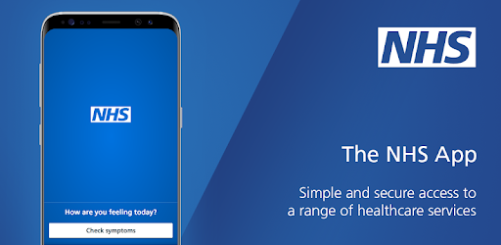

You can now use the new NHS App, a simple and secure way to access a range of NHS services on your smartphone or tablet.

You can use the NHS App to check your symptoms and get instant advice, book appointments, **order repeat prescriptions,** view your GP medical record and more.

If you already use our Hill Lane website, you can continue to use it. You can use the NHS App as well.

For more information go to www.nhs.uk/nhsapp

(You might also need to review existing website content to make sure it covers the different options patients have to connect with online services.)



[**https://www.jostrust.org.uk/about-us?gclid=CjwKCAiAhfzSBRBTEiwAN-ysWIVlPzyexe1oe2o5AZ3ZG0S500W5xKV9ymS5hBKyq90IyKuUZhqHARoCWPkQAvD_BwE**](https://www.jostrust.org.uk/about-us?gclid=CjwKCAiAhfzSBRBTEiwAN-ysWIVlPzyexe1oe2o5AZ3ZG0S500W5xKV9ymS5hBKyq90IyKuUZhqHARoCWPkQAvD_BwE)

Please call the surgery to book an appointment if your smear is due. Please click on the link above for more information, and answers to lots of questions about cervical screening.

"A smear test lasts 5 minutes. The Impact of cervical cancer lasts a lifetime"

Attend your smear test.

**Reduce your risk.**

**[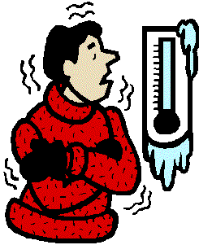](http://www.cliparthut.com/cold-weather-clip-art-clipart-9AMocS.html)**

***Keep Warm, Keep Well***

**Cold homes can have a big impact on your health, and one of the most effective ways of keeping well during winter is to stay warm. This can help prevent colds and flu, as well as more serious conditions, including pneumonia, heart attacks, strokes and depression.**

**Try some of these tips to help keep you warm this winter:**

**✓Draw your curtains at dusk and keep doors closed to block out draughts.**

**✓Have hot drinks regularly, and eat at least one hot meal a day if you can. By eating regularly you can keep energy levels up during winter.**

**✓Instead of wearing one chunky layer of clothing, wear several light layers of warm clothes.**

**✓Keep active in your home if possible, movement will help keep you warm. Wear shoes with a good grip if you need to go outside on cold days.**

**✓Keep your bedroom at 18°C and main living room at 21°C (65 and 70°F). If you can’t heat all the rooms you use, heat the living room during the day and the bedroom just before you go to sleep.**

**✓Try to go and see friends, relatives or neighbours who may be vulnerable to cold weather. Cold weather is especially dangerous for older people or people with serious illnesses, so check up on them if you can. (Bearing in mind Covid restrictions.)**

**For more information on keeping warm and well, visit the following NHS website**

**https://www.nhs.uk/live-well/healthy-body/keep-warm-keep-well/**